Trent Giever

CS &141

Ch 4

4/12/2020

Problem # 4

Code:

///////////////////////////////////////////////////////////////////////

/\*

Programmer: Trent Giever

Assignment Chapter: 4

Purpose: Software Sales

Date modified: 4/13/20

IDE/Tool used: NetBeans 8.2

\*/

package ch.pkg4.pkg1;

import static java.lang.System.out;

import java.util.Scanner;

public class Ch41

{

public static void main(String[] args)

{

Scanner in = new Scanner(System.in);

out.print("Enter the amount buying: ");

int s = in.nextInt();

Software newSale = new Software(s);

out.println(newSale.getTotal());

}

}

/////////////////////////////////////////////////////////////////////////

package ch.pkg4.pkg1;

public class Software

{

private final int COST = 99; //cost of one software

private int quantity; //how many the user is buying

public Software() //defualt constructor

{

quantity =0;

}

public Software(int quantity) //overloaded constructor

{

this.quantity = quantity;

}

public int getQuantity() //return the number that was ordered

{

return quantity;

}

public void setQuantity(int quantity) //abilty to change the order amount

{

this.quantity = quantity;

}

public double getTotal() //returns the total after bulk discounts

{

double total=0; //double variable because of decimal possibility

if(quantity < 1) //if user entered negative amount

total = 0;

else if(quantity < 10) // 1 - 9

total = quantity \* COST; //full price

else if(quantity >= 10 && quantity <= 19) //10 to 19

total = (quantity \* COST) \* .8;// 20% discount

else if(quantity >= 20 && quantity <= 49)// 20 to 49

total = (quantity \* COST) \* .7;//30 % discount

else if(quantity >= 50 && quantity <= 99)//50 to 99

total = (quantity \* COST) \* .6;// 40% discount

else

total = (quantity \* COST) \* .5; // 100+ discount of 1/2 price

return total;//returns the total

}

}

Snip:

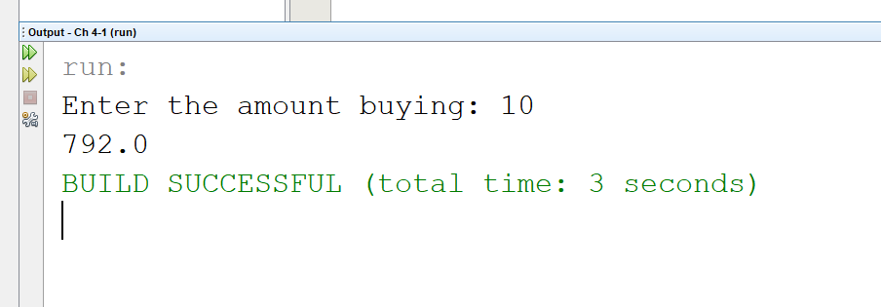

Program # 13

Code:

///////////////////////////////////////////////////////////////////

/\*

Programmer: Trent Giever

Assignment Chapter: 4

Purpose: Body Mass Index

Date modified: 4/13/20

IDE/Tool used: NetBeans 8.2

\*/

package ch.pkg4.pkg2;

import static java.lang.System.out;

import java.util.Scanner;

public class Ch42

{

public static void main(String[] args)

{

Scanner in = new Scanner(System.in);

out.print("Enter your weight");

double weight = in.nextDouble();

out.print("Enter your height");

double height = in.nextDouble();

BMI myWeight = new BMI(weight, height);

out.println(myWeight.index());

}

}

/////////////////////////////////////////////////////////////////////

package ch.pkg4.pkg2;

public class BMI

{

private double weight, height; //holds the users weight and height

public BMI()//default constuctor

{

weight = height =0;

}

public BMI(double w, double h)//overloaded constructor

{

weight = w;

height = h;

}

public double getWeight()// return weight

{

return weight;

}

public void setWeight(double w)//change weight value

{

weight = w;

}

public double getHeight() // return height

{

return height;

}

public void setHeight(double h) //change height value

{

height = h;

}

public String index() //returns the weight

{

String mass="Error"; //creation of String object to print

double BMI = weight \* (703/(height \* height)); // BMI calculation

if(BMI < 18.5) //underweight if

mass = "underweight";

else if(BMI > 25) //overweight

mass = "overweight";

else //ideal

mass = "Ideal";

return "Your weight is " + mass; //returns the string of weight

}

}

Snip:

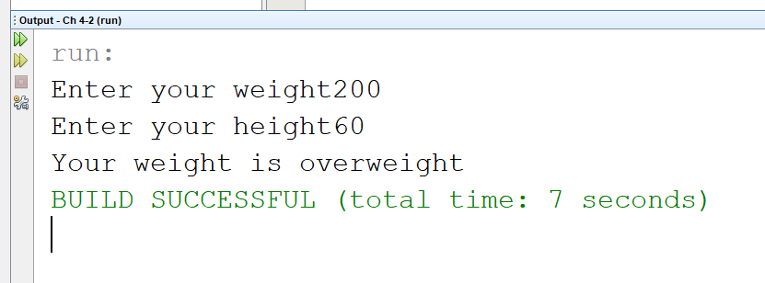

Program # 15

Code:

//////////////////////////////////////////////////////////////////////////////////////////

/\*

Programmer: Trent Giever

Assignment Chapter: 4

Purpose: Book Club Points

Date modified: 4/13/20

IDE/Tool used: NetBeans 8.2

\*/

package ch.pkg4.pkg3;

import static java.lang.System.out;

import java.util.Scanner;

public class Ch43

{

public static void main(String[] args)

{

Scanner in = new Scanner(System.in);

out.print("Enter the number of books bought");

int books = in.nextInt();

BookPoints rewards = new BookPoints(books);

out.println("Points gained: " + rewards.points());

}

}

////////////////////////////////////////////////////////////////////////////////////////////

package ch.pkg4.pkg3;

public class BookPoints

{

private int bought; //how many books bought

public BookPoints() //defualt constructor

{

bought =0;

}

public BookPoints(int bought) //overloaded constructor

{

this.bought = bought;

}

public int getBought() //return # bought

{

return bought;

}

public void setBought(int bought) //set the number bought

{

this.bought = bought;

}

public int points() //gets the users points for the month

{

int points =0; // int variable to hold points

switch(bought) //switch case

{

case 1: //one book

points = 5;

break;

case 2: //two books

points = 15;

break;

case 3: //three books

points = 30;

break;

case 4: //four books

points = 60;

default:

break;

}

return points; //returns books

}

}

Snip:

